Example Site Audit Output

Output contains calculated energy and carbon saving values, plus payback on investment calculations.

Recommendations are linked to actual products from real suppliers.

Replace place holder text with your own text.

Fully editable word document.

White-labelled users can design their own output template.

[Example Company]
Authored by: Your Name

[Survey Company Name/Logo]

Executive Summary

[Write executive summary here…example summary below]
[Example Site] is a large prestige office located in central London. [Example Company] have occupied the whole of the building since 2008.
[The assessment was based on in-depth analysis of half-hourly gas and electric consumption data between 2018 – 2020 and data gathered from a high-level ‘-walk-through’ survey.
The gas data analysis found that consumption data was higher than a benchmark building of similar type and use for all years.
CUSUM analysis identified key events that were further analysed using half-hourly profiling. Profiling found that there was a high baseload in 2018 which was likely instrumental in the year’s high consumption. In addition, all years indicated heating control started earlier and ended later than expected. It was also noted that hot water heating was often left on at weekends. Regression analysis using degree day data indicated poor heating control in 2018.
Electric analysis showed consumption was below benchmark however there is a noticeable increase in benchmark rating as the year's progress driven by a baseload that increased by 33% over the assessment period. Daily energy profiling showed that consumption started earlier and later as the assessment period progressed showing notable weekend consumption.
Both gas and electric analysis showed that there is a significant opportunity for energy savings through better control and investigation in energy consumption anomalies.
The walk-through audit identified additional areas for significant energy savings. It was noted that the heating/hot water systems and controls are inefficient and should be upgraded. The building fabric and widows were found to have poor thermal performance and consideration should be given to their improvement. It was also noted that the building was ‘leaky’ and lost significant energy through ventilation, occupiers should consider draft stripping and sealing off gaps and unused ventilation openings. Various inefficient lights and controls were noted during the survey.

“This site survey identified possible energy savings of 676,301.54 kWh/year, saving £27,470.55 & 130,030.52 kgCO2e”

ESOS Site Audit
Address:
Date:

Phase 3 ESOS regulations require that 95% of an organisation total energy consumption is subjected to an ESOS compliant energy audit.
This building audit forms part of [Example Company]’s Phase 3 ESOS compliance. For companies with large property portfolio, ESOS regulations allow organisations to select a sample of properties to subject to an ESOS compliant audit. This site was selected as a suitable candidate. Sampling methodology and reasoning is retained in the evidence pack [Doc006].
An ESOS energy audit should:
• Measure and understand the energy consumption of your assets and activities.
• Build an energy consumption profile showing where and how your organisation consumes energy. This data can also be used to identify any variations in your energy use, both between areas and over time.
• Identify patterns, build explanations for these and identify any opportunities to reduce your overall energy use through increased levels of efficiency. Implementing such opportunities may provide long-term savings and reduce the impact of future energy price increases for your organisation. Improved efficiency can also boost productivity and growth.

Contents

ESOS Site Audit 3
Identified Energy Saving Opportunities 5
1. Introduction 6
1.1 Assessment Objectives 6
1.2 Scope of the Audit 6
1.3 Limitations 8
1.4 Data Review 8
1.5 Criteria for ranking opportunities for improving energy performance 8
1.6 Basis for calculations, estimates and assumptions. 8
1.7 Site Summary 9
1.8 Site Energy Consumption 9
1.9 Carbon Emissions and Savings 10
2.0 Benchmarks 10
Gas (Fossil Thermal) Benchmark 10
Electricity Benchmark 10
3.0 Energy Saving Opportunities 12
Boiler Replacement 12
Solar Panels (Photovoltaics) 13
Commercial Heat Pump 13
Burner Management Unit 14
Heat Transfer Fluid 15
Energy Monitoring 16
4.0 Energy Profiling 18
4.1 Energy Consumption Profile 18
4.2 Gas Annual Consumption 18
4.3 Electricity Consumption 18
5.0 Act 18
6.0 Disclaimer 18
7.0 Appendices 18

Identified Energy Saving Opportunities

Rank | Energy Saving Measures (ESM) | kWh/annum | Potential Savings (%) | Potential Saving (kWh) | Carbon Saving (kgCO2e) | Saving (£) / year | CAPEX (£) | SPP (Years) | NPV (£)
 | Boiler Optimiser | 522,587.68 | 13.28% | 69,399.64 | 13,420.50 | £6,669.31 | £-5,600.00 | 0.84 | £80,709.97
 | Boiler Replacement | 522,587.68 | 15.31% | 79,987.91 | 15,468.06 | £7,550.86 | £-97,624.00 | 12.93 | £7,014.78
 | Heat Transfer Fluid | 357,858.84 | 8.3% | 29,702.28 | 5,743.83 | £2,854.39 | £-6,040.00 | 2.12 | £31,105.94
 | Energy Monitoring | 554,013.00 | 5% | 27,700.65 | 5,028.88 | £1,170.91 | £0.00 | 0 | £-5,927.58
 | Solar PV | 34,455.38 | 100% | 34,455.38 | 6,662.98 | £13,378.07 | £-35,700.00 | 2.67 | £130,088.12
 | Commercial Heat Pump | 563,734.00 | 71.43% | 402,667.14 | 77,867.77 | £-7,288.28 | £-395,472.00 | 0 | £-481,803.46
 | Establish Energy Policy | 554,013.00 | 1.00% | 5,540.13 | 1,005.78 | £692.09 | N/A | N/A | N/A
 | Reduce heating set point saving | 335,605.00 | 8.00% | 26,848.40 | 4,832.71 | £2,443.20 | N/A | N/A | N/A
 | Potential Energy Savings |  |  | 676,301.54 | 130,030.52 | £27,470.55
Table 1

Figures in this report are based on real products. Links to the actual products and suppliers can be obtained by visiting www.whatsthepayback.com/retrievereport. Click the link to review recommended upgrades, purchase, and arrange installation.
Enter your unique report reference number: 9661671

The cumulative savings are likely be less than predicted if all measures were to be introduced. This is because the reduction in energy use by the introduction of one action, will reduce the savings return of any additional actions, as the baseline energy consumption will have decreased.
Next Steps
- Establish an Action Plan – review, classify, and prioritise ECMs (Energy Conservation Measures), e.g. low to no cost “quick-win” ECMs for immediate implementation; medium to high cost ECMs for detailed development and investment appraisal.
- Assign ownership of actions.
- Establish the Project Delivery and Investment Models, e.g. self-financing, financial lease, energy service companies.
- Manage implementation and evaluation of quick-wins, and develop ECM projects.

1. Introduction
[Write brief description of the company that is being audited noting their business activities and primary energy consuming sources]

1.1 Assessment Objectives
The objectives of the assessment are as follows:
• To provide a quantitative overview of energy performance
• To determine the potential for energy performance improvement based on further assessment to identify specific systems that merit a greater level of attention
• To evaluate overall energy consumption data and analyse energy uses and patterns;
• To identify no-cost and low-cost opportunities for improvement of energy performance
• To advise on best practice and identify areas of possible improvement.

1.2 Scope of the Audit

The delivery of the survey and this accompanying report are based upon the following scope:

Analysis
• Monthly and, where available, half-hourly electricity and gas consumption data

Site Visit
• Review the building's services and its fabric
• Review the operational and energy management practices
• Investigate HVAC plant, lighting and lighting controls and Building Energy Management System (BEMS) control

Energy Efficiency Recommendations
• Identify the main energy saving opportunities.
• Identify and quantify the most cost-effective opportunities, including indicative costs, simple payback periods or lifecycle costing and carbon savings
• Rank opportunities for improving energy performance

Boundaries
The audit is limited to energy consumed at [Example Site].

Time Frame
The audit assessed [Example Site] energy consumption between [Assessment Period]

Statement of confidentiality
[Survey Company] undertakes that it shall not at any time disclose to any person any confidential information concerning the business, affairs, customers, clients or suppliers of [Example Company].

Energy Auditor Information
This audit was completed by [Auditor Name].
The auditors qualification/experience include:
[Enter Experience/Qualification of Assessor(s)]

Methodology
[Example Site] was subject to a high-level audit (a Level 1 audit as defined in ISO 50002). ISO 50002 defines three types of audit, a Level 1 is described as: a basic energy audit which identifies high level opportunities and has enough detail to develop low cost/short payback opportunities.

ISO 50002 defines a minimum level of detail for a Level 1 audit as follows:

• Provides a quantitative overview of energy performance based on overview data;
• Intended to determine the potential for energy performance improvement based on further assessment to identify specific systems that merit a greater level of attention;
• Involves a tour of the site to visually inspect energy using systems;
• Includes an evaluation of overall energy consumption data to analyse energy uses and patterns;
• Identifies no-cost and low-cost opportunities for improvement of energy performance;
• Aimed at moving towards best practice operation of equipment, staff training and building basic capacity to manage energy consumption and use;
• The accuracy of costs and benefits would generally be sufficient for low cost operational expenditures

1.3 Limitations

It was not possible/feasible to install data loggers on individual pieces of equipment to measure consumption.

1.4 Data Review

Utility data
Data provided was [enter data description] e.g. half-hourly gas, half-hourly electric.

Site Data
[Describe site data provided/sourced] e.g. Plans for the site were not to scale. Only small pictures of plant room systems were available. Limited information on building fabric was provided. No other site information was available.

1.5 Criteria for ranking opportunities for improving energy performance

Ranking of energy saving opportunities is a balanced view by the auditor taking in to account the cost and effort required to implement an opportunity against the magnitude of energy saving and potential return on investment.

1.6 Basis for calculations, estimates and assumptions.

[Describe] e.g. Consumption data was half-hourly. The data was found to have some anomalies which were possibly due to billing/equipment errors. Where appropriate these were discounted to allow accurate profiling of actual energy consumption.
The data was analysed using Energy Profiling, Regression analysis and CUSUM analysis.
There is no sub-metered energy data available that may be useful in determining the energy use specific to each building, area or building service and various estimations have been used during the production of this report and any recommendations contained within.

1.7 Site Summary

Site Description: [enter site summary]

Site information/description – e.g. location, no. & type of building(s), age, no. of floors, m2, etc
[Example Site] is a ……

Energy Consuming assets: [enter brief summary of energy consuming assets]

Building Fabric | e.g. Building is brick, concrete, and steel frame. Insulation is unknown. Building fabric is owned and controlled by the landlord. [Example Company] is unable to upgrade the building fabric.
Heating | e.g. HVAC is a centralised system. Heating is provided by 2 x 80kW Valliant boilers.
Cooling | e.g. Cooling is provided by a water cooled Daikin VRV 4 air conditioning system which supplies conditioned air to the store via a ducted unit.
Control | e.g. AC units are controlled by wall mounted units. Heating is controlled by central BMS system.
Ventilation | e.g. Building is mechanically ventilated via air handling units.
Pumps & Fans | e.g. Pumps are single speed motors.
Lighting | e.g. Lighting is LED throughout. T8 Fluorescent Tubes are installed on underground car park.
Hot water | e.g. Hot water is provided by electric Zip point of use water heaters.

1.8 Site Energy Consumption

The table below provides the annual energy consumption and cost of consumption during the subject year.
Utility | Energy Consumption |  | Cost
 | kWh/year | % | Rate (£) | £/year | %
Electricity | 63,923.00 | 11.54 | 0.39 | £24,610.36 | 35.56
Gas | 490,090.00 | 88.46 | 0.09 | £44,598.19 | 64.44
Total | 554,013.00 |  |  | £69,208.55

Total carbon emissions equated to 107,135.03kgCO2e/year. Carbon savings identified in this report equate to 130,030.52 kgCO2e/year. A potential cumulative saving of 122.07%

1.9 Carbon Emissions and Savings

2.0 Benchmarks
Effective energy analysis is an important tool in providing meaningful energy efficiency improvements. This section looks to provide a general overview of [Example Site] energy consumption and identify possible areas for improvement or further investigation. Benchmarks were based on TM46 methodology which provides typical gas and electric benchmark ratings for [Benchmark Type]. The benchmark figures are energy consumed (kWh) per meter squared of floor space.

Gas (Fossil Thermal) Benchmark
To provide an accurate comparison between years, consumption was weather normalised using degree day data. The charts below benchmark [Example Site]’s gas consumption. Benchmarking found that the sites gas consumption is [describe benchmark findings]

Electricity Benchmark

The chart below benchmarks [Example Site] against a similar building of similar use. Benchmarking found that the site’s electricity energy consumption is [describe].

A benchmark consumption rating better than typical, could be considered acceptable, however, benchmark data is now quite old and is based on buildings from the early 2000’s. Technology and associated efficiencies have moved on significantly.

3.0 Energy Saving Opportunities

Boiler Replacement
The boiler(s) on site were noted to be inefficient. Modern boilers can have efficiencies of up to 97%, providing significant energy, cost and carbon savings.

Boiler Replacement |  | Annual Savings
 |  | Monetary  £7,550.86 |  | Energy  79,988 kWh |  | Carbon  15,468 kgCO₂e
 |  | Financial Statistics
 |  | Total Investment  £97,624.00 | Payback Time  12.93 Years |  | ROI (15 years)  £7,014.78

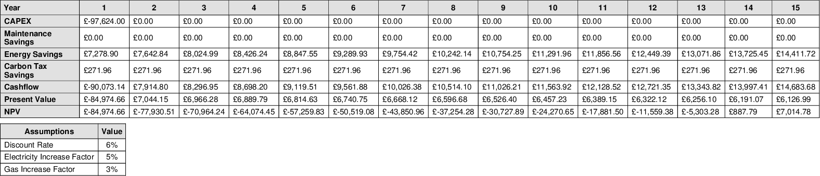

Solar Panels (Photovoltaics)
Solar panels, or photovoltaic (PV), convert sunlight directly into electricity. The estimated lifetime of a photovoltaic module is 30 years and performance would be expected to remain at over 80% of the initial power after 25 years. The carbon footprint of manufacturing photovoltaic has decreased by approximately 50% in the last 10 years due to performance improvements, raw material savings and manufacturing process improvements.

Solar PV |  | Annual Savings
 |  | Monetary  £13,378.07 |  | Energy  34,455 kWh |  | Carbon  6,663 kgCO₂e
 |  | Financial Statistics
 |  | Total Investment  £35,700.00 | Payback Time  2.67 Years |  | ROI (15 years)  £130,088.12

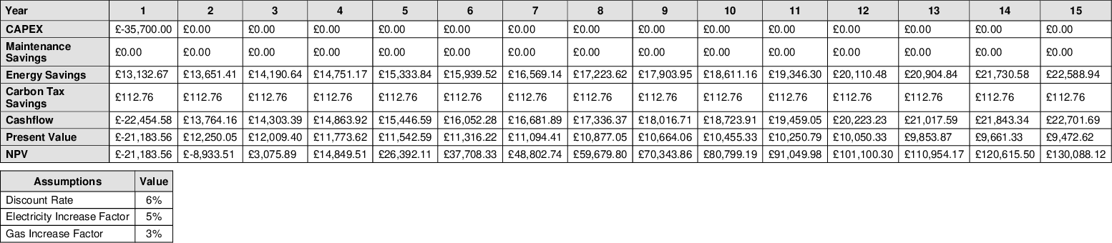

Commercial Heat Pump
Air source heat pumps (ASHPs) use the external air as a heat source to provide heat for buildings. Air source heat pumps can reduce energy consumption, fuel bills and carbon emissions, particularly where there is no mains gas supply, and so alternative heating systems would consume electricity, liquid petroleum gas (LPG), oil, or coal. Because they provide lower-temperature hot water over long durations, they are generally most suitable for highly insulated, air-tight buildings.

Commercial Heat Pump |  | Annual Savings
 |  | Monetary  £-7,288.28 |  | Energy  402,667 kWh |  | Carbon  77,868 kgCO₂e
 |  | Financial Statistics
 |  | Total Investment  £395,472.00 | Payback Time  Never |  | ROI (15 years)  £-481,803.46

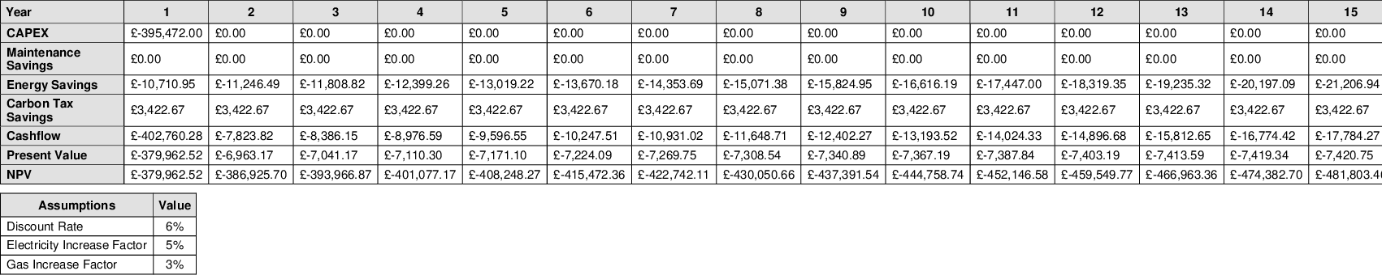

Burner Management Unit
Installing boiler optimisation management units to existing boilers can achieve significant energy savings. The unit is installed between the thermostat and the burner valve of your current boiler, working with the existing controls. The unit optimises the firing pattern of the boiler by creating fewer, but slightly longer, burning periods. The overall effect is to reduce the amount of time the boiler is burning and therefore consuming less fuel. The units create immediate identifiable savings in energy consumption costs and carbon reductions. With an in-built monitoring and verification interface facility, energy savings can be shown in real-time.

Burner Management Unit |  | Annual Savings
 |  | Monetary  £6,669.31 |  | Energy  69,400 kWh |  | Carbon  13,421 kgCO₂e
 |  | Financial Statistics
 |  | Total Investment  £5,600.00 | Payback Time  10 Months |  | ROI (15 years)  £80,709.97

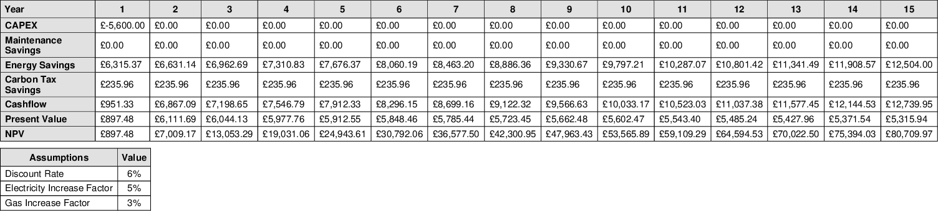

Heat Transfer Fluid
Endotherm additive is 100% organic, non-corrosive and has inhibitor properties. A dose of Endotherm is simply poured into your wet heating system. Developed and manufactured in the UK, it has been independently proven to create the savings stated in this report by increasing the surface tension of the water, which improves heat transfer rate and efficiency, enabling rooms or plant reach a set temperature quicker and staying warmer for longer.

Heat Transfer Fluid |  | Annual Savings
 |  | Monetary  £2,854.39 |  | Energy  29,702 kWh |  | Carbon  5,744 kgCO₂e
 |  | Financial Statistics
 |  | Total Investment  £6,040.00 | Payback Time  2.12 Years |  | ROI (15 years)  £31,105.94

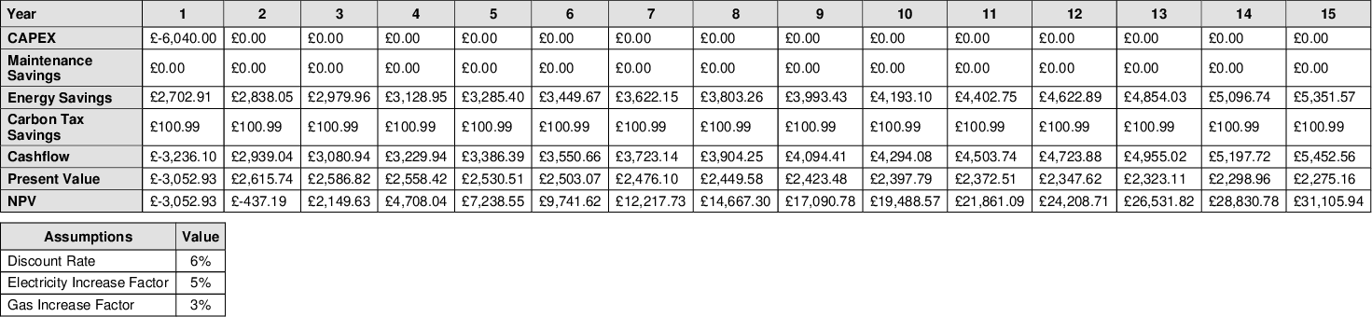

Energy Monitoring
It is recommended that the use of smart energy management software is considered. If smart meters are not already installed, contact your supplier or WTP to discuss possible smart monitoring solutions. Energy management software allows users to track and analyse a very wide range of metrics. This includes electricity, heat and related parameters (such as voltage, power factor etc.). Furthermore, environmental metrics such as temperature, degree days, humidity, air quality and irradiance can be supported. Between 2004 and 2006, the Carbon Trust installed 582 smart meters in SME’s. The study has demonstrated that SMEs using advanced metering can identify an average of 12% carbon savings and implement an average of 5% carbon savings through reduced utility consumption (CTC 713 Advanced metering for SMEs’).

Energy Monitoring |  | Annual Savings
 |  | Monetary  £1,170.91 |  | Energy  27,701 kWh |  | Carbon  5,029 kgCO₂e
 |  | Financial Statistics
 |  | Total Investment  £0.00 | Payback Time  30.75 Years |  | ROI (15 years)  £-5,927.58

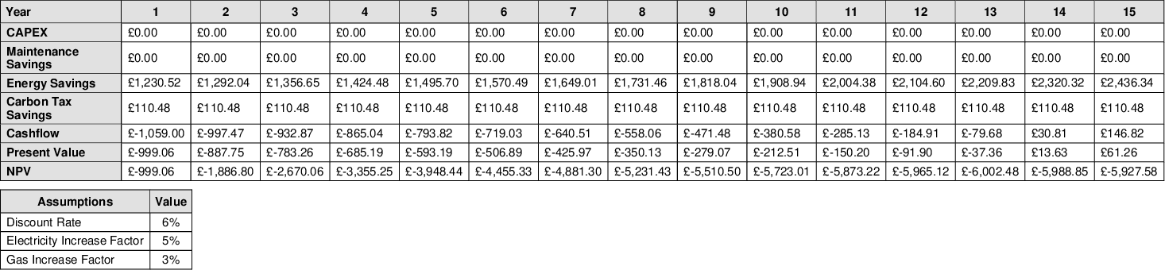

4.0 Energy Profiling
Effective energy analysis is instrumental in providing meaningful energy efficiency improvements. This section looks to provide a general overview of [Example Site] historic energy consumption and identify possible areas for improvement or further investigation.

4.1 Energy Consumption Profile

4.2 Gas Annual Consumption

4.3 Electricity Consumption
4.4 Regression analysis

5.0 Act
This report provides estimated savings and payback periods for a range or energy-efficient technologies deemed to be appropriate for the subject building. In most cases, payback periods are less than a couple of years, providing significant savings over time.
www.whatsthepayback.com is a unique system which links proposed energy-saving opportunities to actual products. In one click, users can connect to suppliers of recommended technologies.
Visit www.whatsthepayback.com/retrievereport and enter the report reference number detailed on page 4 of this document.

6.0 Disclaimer
The information presented is based on a combination of public domain sources, data supplied by companies, in-house knowledge and analysis and engagement with stakeholders. While the information is provided in good faith, the ideas presented in the report must be subject to further investigation, and consider other factors not presented here, before being taken forward. Therefore, the authors disclaim liability for any investment decisions made based on the results of this report.

7.0 Appendices
CO2 Grid Electricity 1kWh = 0.21107 kgCO2e (includes T&D emissions)
CO2 Natural Gas 1kWh = 0.18254 kgCO2e (Gross)
CO2 Fuel Oil 1kWh = 0.28526 kgCO2e (Net)
CO2 Gas Oil 1kWh = 0.27319 kgCO2e (Net)
CO2 LPG 1kWh = 0.23031 kgCO2e (Net)
CO2 Wood Chips 1kWh = 0.01053 kgCO2e
CO2 Wood Logs 1kWh = 0.01053 kgCO2e
CO2 Wood Pellets 1kWh = 0.01053 kgCO2e
Reference: UK Government Conversion Factors 2022

An average electricity unit rate of 00 p/kWh and a natural gas rate of 00 p/kWh have been used. These unit rates have been used throughout this report in helping to determine the likely cost savings and payback periods of recommendations being made. [AMEND/DELETE AS NECESSARY]

